**Instructions to Build and Run the Application:**

Download the application from git repository from the link.

Build application using mvn command or by importing project in spring tool suite and run from there.

**Database:**

“**Apache Derby**” an in-memory database is used for this test. Test data will be loaded automatically once the application starts running. **Spring-batch** is used to load the file from sample-data.csv.

**MVC:**

To fetch data from database **spring-data-jpa** is used. This will create a repository as interface between service layer and table. Once the data has fetch from db will be exposed as rest webservice using the endpoint. Below are the endpoints.

To view all the data from table:

<http://localhost:9090/monthlymasterbk>

I used postman as a client to get and post data.

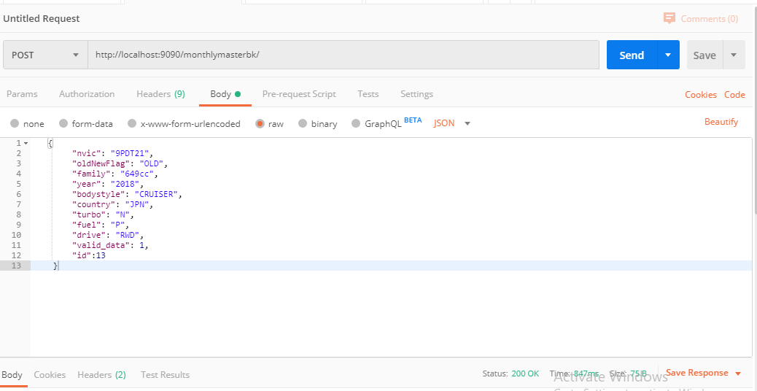

Get All the Data:

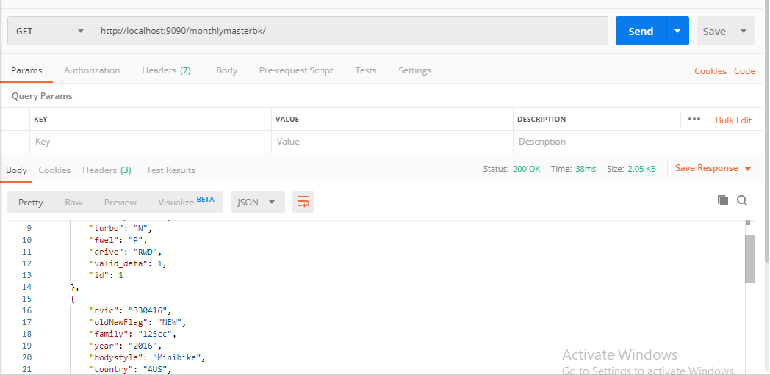

To Update a record:

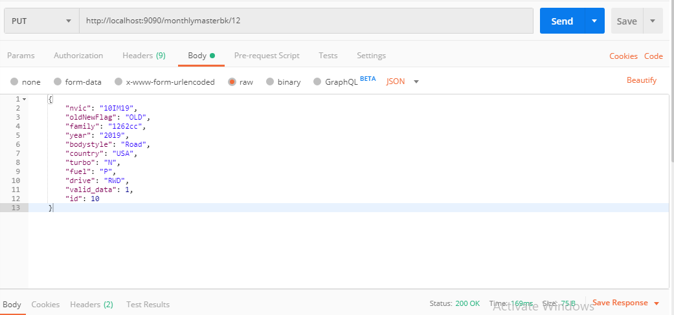

To execute the “storedprocedure” like functionality:

<http://localhost:9090/monthlymasterbk/validate>

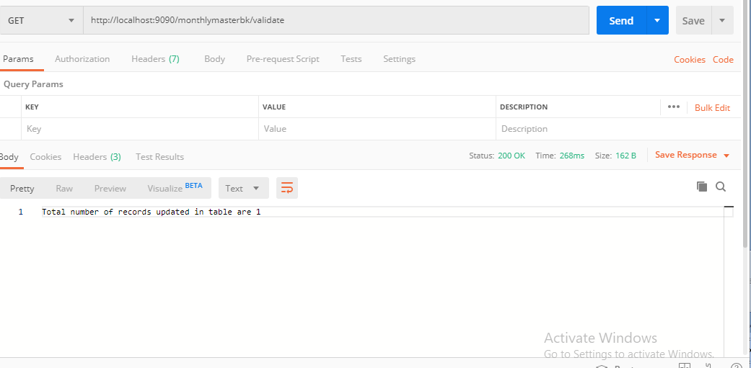

**Topics not covered under this application:**

Though there is much scope for the addition of loggers, exception handling I couldn’t work on them. Also, couldn’t manage to work on testing part.